Gap Analysis – Current [Enter Company Name] Safety Management Processes against ISO 45001:2018

Date

Section 1 - Summary:
Summary of areas of compliance:

Summary of key areas requiring further work:

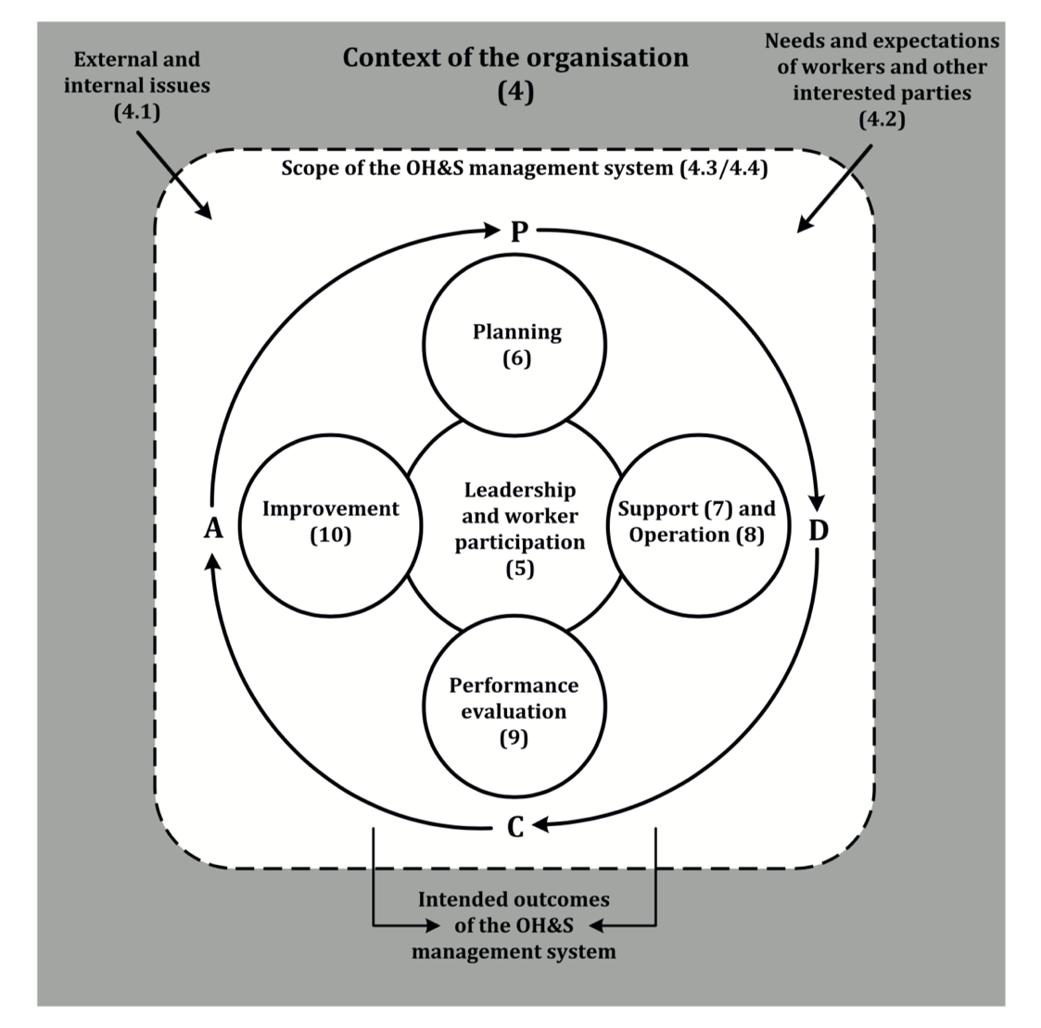

Section 2 – Gap Analysis Against ISO 45001
Clause | Audit Checklist | Document | Records/ Evidence/ Output
Section 4 – Context of the Organisation
4.1 | Have you determined the external and internal issues that are relevant to your organization’s purpose and the achievement of customer satisfaction and the organization’s strategic direction? | In Place:  - e.g. Internal and external issues identified in Business Risk Register.  - Reviewed quarterly in management meeting  Action Required:  - Issues requiring further action could be more clearly identified. | In Place:  - e.g. Business Risk Register.  Action:  - Add actions, responsibilities and timeframes column to Business Risk Register
4.1 | Do you have a way of reviewing and monitoring these on a regular basis? | In Place:  Action Required: | In Place:  Action:
4.2 | Have you determined the needs and expectations of interested parties that are relevant to the Management System (IMS)? | In Place:  Action Required: | In Place:  Action:
4.2 | Do you have a way of reviewing and monitoring these on a regular basis? | In Place:  Action Required: | In Place:  Action:
4. 3 | Has the scope of the IMS been determined taking into account the external and internal issues, interested parties and your products and services? | In Place:  Action Required: | In Place:  Action:
4.4 | Has your IMS been established including the processes needed and their sequence and interaction? | In Place:  Action Required: | In Place:  Action:
4.4 | Have the criteria for managing these been established together with responsibilities, methods, measurements and related performance indicators needed to ensure the effective operation and control? | In Place:  Action Required: | In Place:  Action:
Section 5 – Leadership
5.1 | Has top management taken accountability for the effectiveness of the IMS (environment, quality and safety)? | In Place:  Action Required: | In Place:  Action:
5.2 | Is the OHS Policy documented, authorized, communicated and made available to interested parties? | In Place:  Action Required: | In Place:  Action:
5.1 | Have the requirements for the IMS been integrated into the business processes and have management promoted awareness of the systems approach? | In Place:  Action Required: | In Place:  Action:
5.1 | Have the risks and opportunities that are relevant to the SMS been established (i.e. opportunities to facilitate improved OHS performance or threats to OHS performance)? | In Place:  Action Required: | In Place:  Action:
5.3 | Has the organization established and communicated the responsibilities and authorities for the effective operation of the IMS? | In Place:  Action Required: | In Place:  Action:
5.4 | Consultation and Participation of Workers | In Place:  Action Required: | In Place:  Action:
Section 6 – OHS Planning
6.1.1 | Have the risks and opportunities that need to be addressed to give assurance that the IMS can achieve its intended result(s) been established? | In Place:  Action Required: | In Place:  Action:
6.1.2.1 | Is there a process to identify hazards that considers: how work is organised, social factors, leadership and culture; routine and non-routine activities; infrastructure, materials, equipment, substances and physical conditions in the workplace; construction and maintenance; past incidents and their causes; emergency situations; people (workers, contractors, visitors, others, those in the vicinity of the workplace and workers at other locations not under direct control of the organisation; design of work areas, equipment, processes, and work organisation; situations in the vicinity of the workplace (under the control of the organisation and not under direct control); changes | In Place:  Action Required: | In Place:  Action:
6.1.2.2 | Has the organisation established a process to assess OH&S risks from identified hazards, considering current controls; determined risks to the OHS management system and defined its risk methodology and criteria | In Place:  Action Required: | In Place:  Action:
6.1.2.3 | Has the organisation established a process to assess OHS opportunities to enhance OHS performance (including consideration of: planned changes; adapting work, the way work is organised or the work environment to workers; opportunities to eliminate hazards) and opportunities for the OHS system | In Place:  Action Required: | In Place:  Action:
6.1.3 | Have compliance obligations relating to aspects been identified, updated and considered in planning, implementing and maintaining the IMS? | In Place:  Action Required: | In Place:  Action:
6.1.4 | Has the organization planned actions to address:  Risks and opportunities?  Legal requirements?  To prepare and respond to emergency events?  How to integrate and implement actions in the OHS management systems and integrated them into the system processes and the effectiveness of actions taken? | In Place:  Action Required: | In Place:  Action:
6.2 | Have the objectives been established at relevant departmental and individual levels with the business (OHS, environment, quality)? | In Place:  Action Required: | In Place:  Action:
Section 7 – Support
7.1 | Has the organization determined and provided the resources needed for the establishment, implementation, maintenance and continual improvement of the OHS MS? | In Place:  Action Required: | In Place:  Action:
7.2 | Has the organization ensured that those persons who can affect OHS performance are competent on the basis of appropriate education, training, or experience or taken action to ensure that those persons can acquire the necessary competence? | In Place:  Action Required: | In Place:  Action:
7.3 | Have persons working on behalf of the organisation been made aware of the management system, Policy commitments, objectives and their role in managing OHS risks/requirements? | In Place:  Action Required: | In Place:  Action:
7.4 | Has the organisation determined what, with whom, when and methods of internal/external communication? Are compliance obligations relating to communication considered? | In Place:  Action Required: | In Place:  Action:
7.5 | Has the documented information required by the standard and necessary for the effective implementation and operation of the IMS been established? | In Place:  Action Required: | In Place:  Action:
Section 8 – Operations
8.1.1 | Are OHS control measures and criteria developed and implemented across relevant stages of the life cycle (including design)? | In Place:  Action Required: | In Place:  Action:
8.1.2 | Eliminating hazards and reducing OH&S risk – is the hierarchy of control considered in managing risk? | In Place:  Action Required: | In Place:  Action:
8.1.3 | When changes are planned are they carried out in a controlled way and actions taken to mitigate any adverse effects? | In Place:  Action Required: | In Place:  Action:
8.1.4 | Are processes established to control procurement of products and services in order to ensure their conformity to OH&S management system requirements? | In Place:  Action Required: | In Place:  Action:
8.2 | Have potential emergency events been identified? Are response processes prepared and tested? | In Place:  Action Required: | In Place:  Action:
Section 9 – Performance Evaluation
9.1 | Has the organization determined • what needs to be monitored and measured and • the methods for monitoring, measurement, analysis and evaluation, to ensure valid results? | In Place:  Action Required: | In Place:  Action:
9.1.2 | Is there a process for evaluating compliance with legal and other requirements? | In Place:  Action Required: | In Place:  Action:
9.2 | Have internal system and project audits been planned, scheduled and conducted? | In Place:  Action Required: | In Place:  Action:
9.1.3 | Have methods of evaluating performance data been identified and implemented? | In Place:  Action Required: | In Place:  Action:
9.3 | Are management reviews planned and carried out? Do they cover inputs/outputs identified in the Standards? | In Place:  Action Required: | In Place:  Action:
Section 10 – Improvement
10.1 | Has the organization determined and selected opportunities for improvement and implemented the necessary actions improve OHS performance? | In Place:  Action Required: | In Place:  Action:
10.2 | Has the organization appropriate processes for managing nonconformities and the related corrective actions? | In Place:  Action Required: | In Place:  Action:
10.3 | Has the organization decided on how it will address the requirement to continually improve the suitability, adequacy, and effectiveness of the IMS? | In Place:  Action Required: | In Place:  Action:

Appendix A – Summary Documented Information Required by ISO 45001:2018

“Maintain As” or “Maintained” (formerly “document”) | “Retain As” (formerly “record”)
- 4.3 Scope  - 5.2 OH&S policy  - 5.3 Organizational roles, responsibilities, accountabilities and authorities  - 6.1.1 Actions to address risks and opportunities – General  - 6.1.2.2 Assessment of OH&S risks and other risks to the OH&S management system  - 6.1.3 Determination of legal requirements and other requirements  - 6.2.2 Planning to achieve OH&S objectives  - 7.5.1 General (documented information determined by the organization as being necessary for the effectiveness of the OH&S management system.)  - 8.1 Operational planning and control  - 8.6 Emergency preparedness and response  - 10.3 Continual improvement | - 6.1.2.2 Assessment of OH&S risks and other risks to the OH&S management system  - 6.1.3 Determination of legal requirements and other requirements  - 6.2.2 Planning to achieve OH&S objectives  - 7.2 Competence  - 7.4.1 Communication - General  - 8.1 Operational planning and control  - 8.6 Emergency preparedness and response  - 9.1 Monitoring, measurement, analysis and evaluation - General  - 9.1.2 Evaluation of compliance  - 9.2.2 Internal audit process  - 9.3 Management Reviews  - 10.2 Incident, nonconformity and corrective action  - 10.3 Continual improvement

